­

PROJECT:

**CONSOLE OPERATED COMPUTER CONTROLLING AND DETAILS DETECTION SYSTEM**

**PROJECT TEAM MEMBERS:**

* **11508 Muzamil Khan**

**SUBMITED TO: MAM UMM-E-KULSOOM**

**CONSOLE OPERATED COMPUTER CONTROLLING AND DETAILS DETECTION SYSTEM**

|  |  |
| --- | --- |
| **MEMBER DETAILS & PERSONAL INFORMATION** | |
| **NAME** | **Muzamil Khan** |
| **STUDENT ID** | **11508** |
| **PHONE NUMBER** | **03363506933** |

***Submitted to: UMME-E-KULSOOM***

**INTRODUCTION**

**CONSOLE OPERATED COMPUTER CONTROLLING AND DETAILS DETECTION SYSTEM is basically a mini operating system. We tried to make our OS in such a way that user can detect his computer details in one click.**

**Insha’Allah Our project will be helpful for those beginner users who don’t know how to see their system details.**

**CONSTRUCTION OF PROJECT**

**Our project is divided into 2 parts. First is for user and second is for admin. When user will login as user then our mini OS will ask him to enter his ID and name. when user will enter his name then his name and details will be gone in a text file place in my laptop and that file will be un accessible for user so that it will work as security control because admin will be able to access that file by entering his name and password. And the remaining features will be working through CMD, google chrome, and processes.**

**FEATURES**

**ASCII art have been used for styling of first page and the last page.**

**We have worked on 7 main features:**

* **File and directory details system**
* **Browsing internet**
* **See available Wi-Fi**
* **See previously connected Wi-Fi history**
* **Processor details and speed**
* **Ip configuration**
* **System specs/info**

**FUTURE MODIFICATION**

**In future we will work on admin side and will be using data base in it so that we can save the access history of users in a table of data base and admin will be able to share or give access to user by their request.**

**And secondly, he will try to make it in a GUI based application that will be more comfortable to the user.**

**We want our browsing on console screen in future.**

**GOAL**

**Our goal is to make sure that user can get his important details on one click.**

**And specially, we have make sure that our project code will not break at any point Insha’Allah.**

**METHODOLOGY**

**Our project is the first step to building our grand OS in future. It’s following user based methods and every class and function is consisting of recursion to avoid the code break. Most of project functionalities are from built-on classes and functionalities of visual studio. And many are running with the help of CMD.**

**CONCLUSION**

**We just want to conclude our report in these word “our OS will be helpful for those clients who don’t have any idea how to see their system details, and our OS will be really helpful for them because they’ll be able to find these features by one click”.**

**EXPLANATION OF 1 FEATURE**

**CLASS TITLE: In this screen we use ASCII art for the better look**

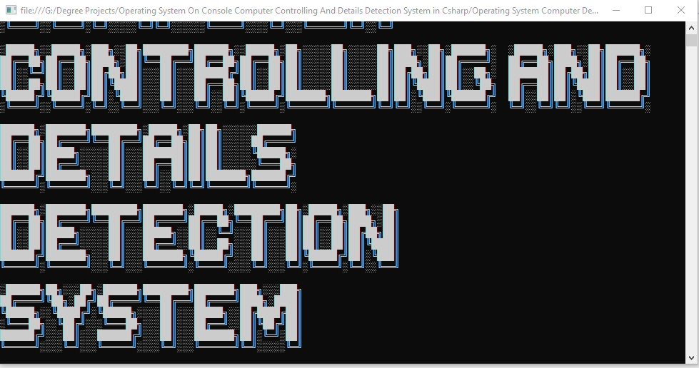

**SEVEN FEATURES LIST FROM USER CLASS:**

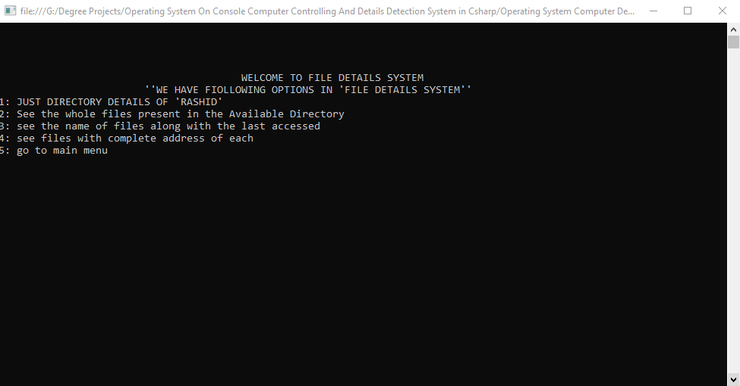

**FINDING PREVIOUS CONNECTED WIFI HISTORY:**

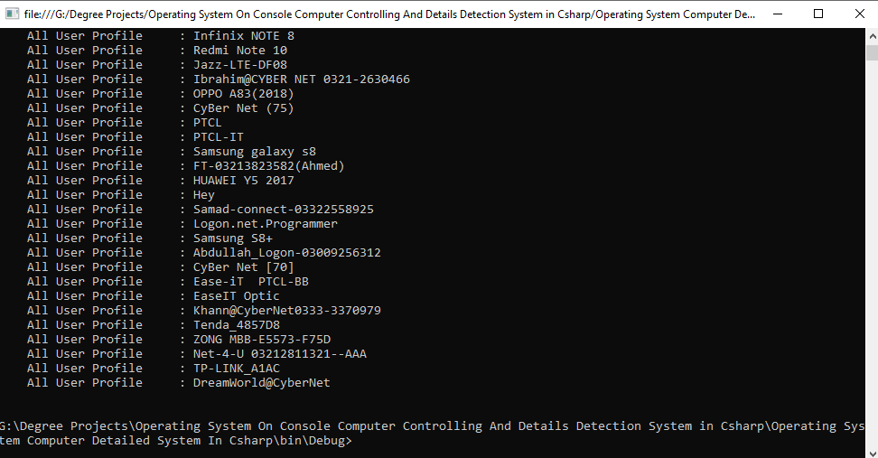

**ENDING PAGE**

